

American International University-Bangladesh (AIUB)

**Department of Computer Science Faculty of Science &Technology (FST) Spring 23 24**

**Bangladesh Metro Rail Mobile Ticketing & NFC Integration System**

Software Requirement Engineering Sec: **B**

Project submitted

By

Md. Ibrahim Khalil Lajim (21-45123-2) Sheikh Atiya Ava (21-45006-2)

Faisal Hossain (21-45107-2)

Shakil Khan (21-45108-2)

# Checked By Industry Personnel

Name:

Designation:

Company:

Sign:

Date:

# PROBLEM DOMAIN

## Background to the Problem

Dhaka, the bustling capital of Bangladesh, grapples with daily traffic congestion. The Dhaka Metro Rail, a revolutionary infrastructure project, aims to ease this burden and provide a faster, more reliable mode of transportation. However, the current ticketing system, reliant on physical queues at stations, creates bottlenecks and hinders passenger experience.

## Solution to the Problem

This project proposes a cutting-edge solution: a mobile application and Near-Field Communication (NFC) integration for the Bangladesh Metro Rail ticketing system. This user- centric approach will transform daily commutes:

* + - **Mobile App:** Passengers can download a user-friendly app to:
      * Purchase tickets (single or return) for specific journeys.
      * Select departure and arrival stations.
      * Choose travel dates and times (if applicable).
      * Securely pay for tickets using various options (credit cards, mobile wallets).
      * View trip details, download tickets (QR code or digital format), and manage travel history.
      * Access real-time information on ticket availability and estimated travel times.
    - **NFC Integration:** Stations will be equipped with NFC readers. Passengers can simply tap their smartphones (with the app and active ticket) at the reader for quick and contactless entry.

## Why is this solution ideal?

* + - **Convenience:** Passengers can purchase tickets on the go, eliminating queues and station wait times.
    - **Efficiency:** The system streamlines the ticketing process, improving overall passenger flow.
    - **Security:** Secure payment gateways and encrypted data storage to ensure user safety.
    - **Accessibility:** The app caters to diverse users, including those unfamiliar with Bengali text.
    - **Scalability:** The system can adapt to future growth in ridership and system expansion.

## Existing Solutions:

Several metro systems globally have successfully implemented mobile ticketing and contactless fare collection using NFC technology. Studying these models will provide valuable insights into Bangladesh's unique needs.

# SOLUTION DESCRIPTION

## System Features

* + - **User Registration and Login:** Secure account creation with basic information for personalized ticketing.
    - **Ticket Purchase:** Intuitive interface for journey selection, fare calculation, and secure payment processing.
    - **Payment Gateway Integration:** Integration with trusted payment gateways for seamless transactions.
    - **Ticket Management:** Easy access to purchased tickets, QR code downloads, and travel history.
    - **Real-time Information:** Live updates on ticket availability, travel times, and any service disruptions.
    - **Push Notifications:** Timely alerts about trip details, boarding gate updates, and delays.
    - **NFC Integration:** Secure and contactless fare validation through NFC-enabled smartphones.
    - **Multilingual Support:** The app will be available in Bangla and English for wider accessibility.
    - **Customer Support:** A dedicated help section within the app and contact information for inquiries.

## Quality Attributes:

* + - **Security:** User data and transaction details will be protected using industry-standard encryption protocols.
    - **Performance:** The app will be optimized for smooth operation even on devices with varying processing power and internet connectivity.
    - **Usability:** An intuitive and user-friendly interface will ensure a smooth experience for passengers of all technical abilities.
    - **Availability:** The system will be highly available with minimal downtime for maintenance.

## UML Diagrams

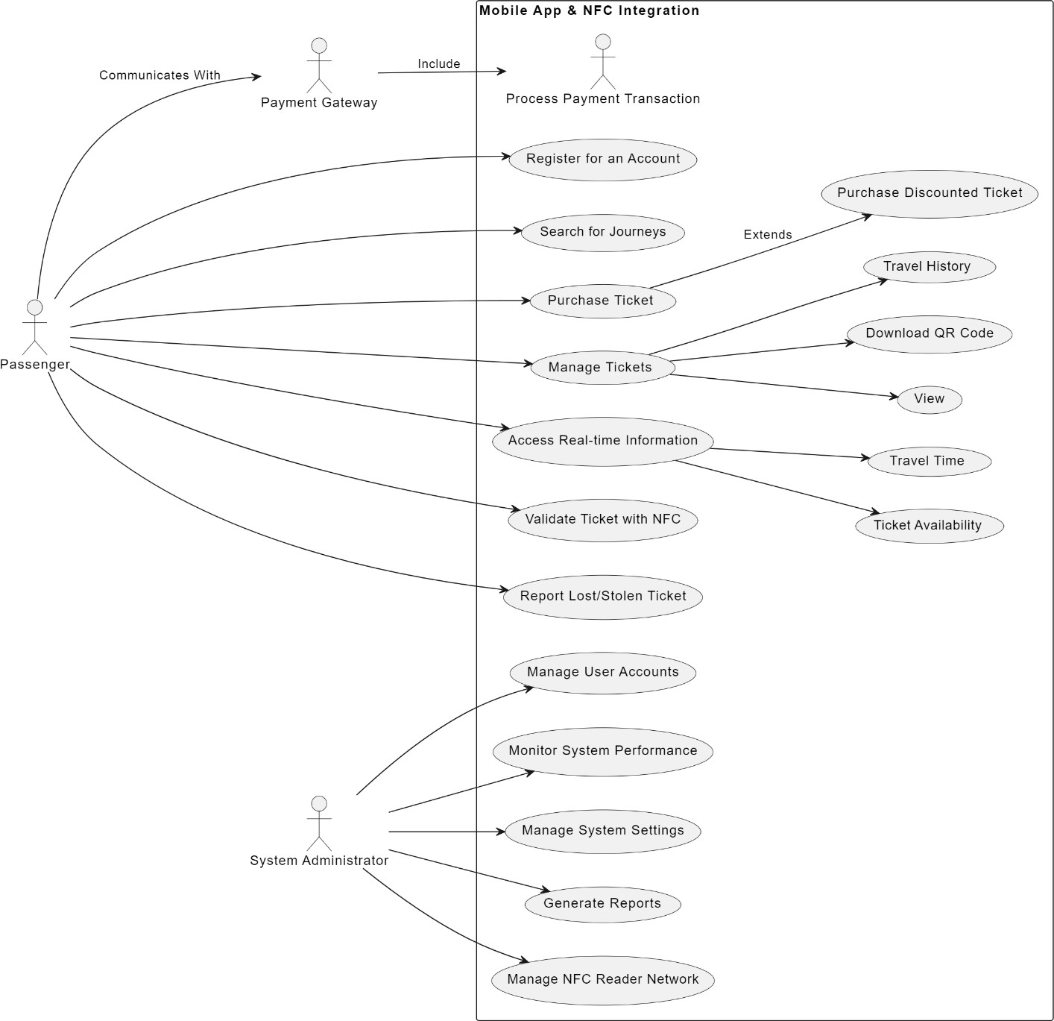

Figure1: use-case diagram

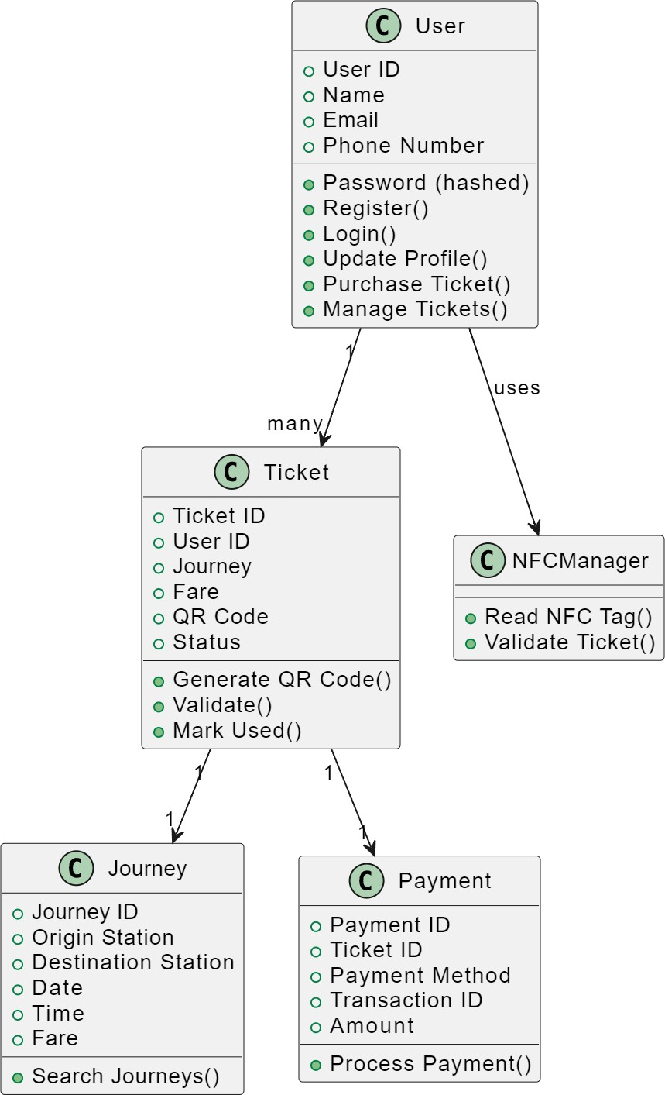

Figure 2: Class Diagram

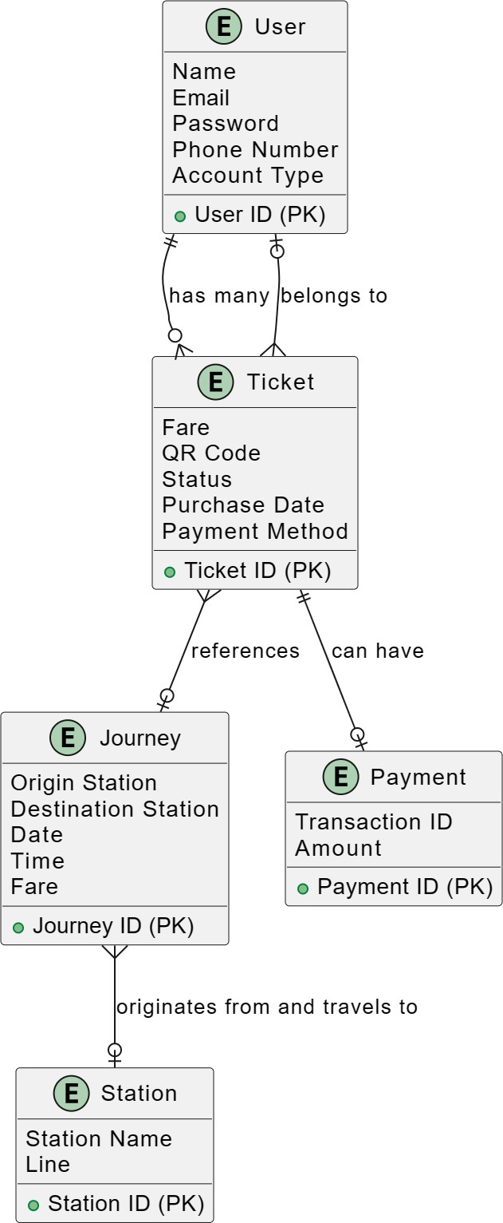

Figure 3: E-R Diagram

# A black and grey striped background Description automatically generatedSocial Impact

* **Reduced Traffic Congestion:** By encouraging public transport use, the system will contribute to decongesting Dhaka's roads.
* **Improved Air Quality:** Fewer vehicles on the road will lead to cleaner air and a healthier environment.
* **Enhanced Accessibility:** The app's features will cater to passengers with disabilities, promoting inclusive mobility.
* **Economic Benefits:** Efficient public transport fosters economic activity by ensuring a smoother flow of goods and services.

# A black and grey background Description automatically generated with medium confidenceDevelopment Plan with Project Schedule

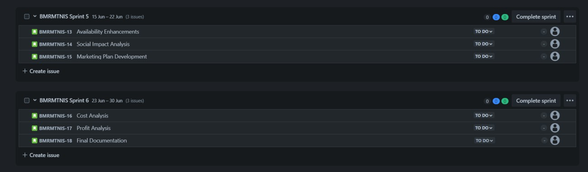

1. **Marketing Plan**

## Short-term (Launch):

* Partner with the Dhaka Mass Transit Company Limited (DMTCL) for official promotion through their channels (website, social media, station displays).
* Collaborate with local media outlets (newspapers, radio, TV) to reach a wider audience.
* Launch social media campaigns highlighting the app's convenience and benefits.
* Offer incentives for early adopters, such as discounts on first few ticket purchases.

## Long-term (Growth):

* Develop a comprehensive marketing strategy targeting different demographics (students, professionals, etc.).
* Partner with ride-hailing services for seamless integration with public transportation journeys.
* Explore incorporating location-based services within the app for real-time arrival and departure information.
* Analyze user data to understand travel patterns and optimize the app for improved efficiency.
* Partner with local businesses near metro stations for cross-promotional opportunities (e.g., discounts for metro ticket holders at local shops).
* Conduct user surveys and gather feedback to continually improve the app's features and user experience.

# Cost and Profit Analysis

**Cost Analysis:**

1. **Development Costs:**
   * **Mobile App Development:**
     + **Hourly Rate:** $25 - $50 per hour
     + **Estimated Time:** 3000 - 5000 hours
     + **Estimated Cost:** $75,000 - $250,000

## NFC Integration:

* + - **Development Effort:** Lower than app development due to existing libraries and APIs
    - **Estimated Cost:** $25,000 - $50,000

## Backend Development:

* + - Cost depends on server infrastructure, database needs, and integration complexity.
    - **Estimated Cost:** $20,000 - $50,000

## Hardware Costs:

* + **NFC Readers:**
    - Cost per reader varies depending on features and range.
    - Estimate 100 readers for major stations (cost can be adjusted based on station coverage).
    - **Estimated Cost:** $50,000 - $100,000

## Other Costs:

* + **Project Management:** $10,000 - $20,000
  + **Quality Assurance (QA) Testing:** $10,000 - $20,000
  + **UI/UX Design:** $5,000 - $10,000
  + **Server Infrastructure:** Ongoing cost based on usage and scalability needs.

**Total Estimated Cost:** $195,000 - $500,000

# Reference

1. **Dhaka Mass Transit Company Limited (DMTCL) Website:** <https://dmtcl.gov.bd/>

## Mobile Ticketing Market - Global Forecast to 2028:

<https://www.grandviewresearch.com/industry-analysis/smart-ticketing-market>

[pen_spark](https://www.grandviewresearch.com/industry-analysis/smart-ticketing-market)

1. **Android NFC Development Guide:**

<https://developer.android.com/develop/connectivity/nfc/nfc>

1. **Apple Core NFC Framework:** <https://developer.apple.com/documentation/corenfc>
2. **Transport for London (TfL) Mobile Ticketing App:** [https://tfl.gov.uk/fares/how-to-pay-](https://tfl.gov.uk/fares/how-to-pay-and-where-to-buy-tickets-and-oyster/tfl-oyster-and-contactless-app) [and-where-to-buy-tickets-and-oyster/tfl-oyster-and-contactless-app](https://tfl.gov.uk/fares/how-to-pay-and-where-to-buy-tickets-and-oyster/tfl-oyster-and-contactless-app)
3. **Shenzhen Metro QR Code Ticketing System:**

<http://www.szpsq.gov.cn/english/Life/Transportation/content/post_7611217.html>